

Programme | : | M.Tech Int Software Engineering | Semester | : | Fall 2026-2027
Course | : | Database Systems Lab | Code | : | IASWE206
Faculty | : | Dr. M. Premalatha | Slot | : | L31+L32

Date: 12-10-2026
Ex No: 8
PL/SQL Basics

Note:
LMS Submission Format [Word File]
Regno, name
Course code, course title
Slot
Faculty Name
Question
SQL Query
Screenshot

Ex:
SQL> create table student_mp(regno varchar(4), sname char(10), mobno number(10), dob date);
Table created.

SQL> desc student_mp
Name Null? Type
----------------------------------------- -------- ----------
REGNO VARCHAR2(4)
SNAME CHAR(10)
MOBNO NUMBER(10)
DOB DATE
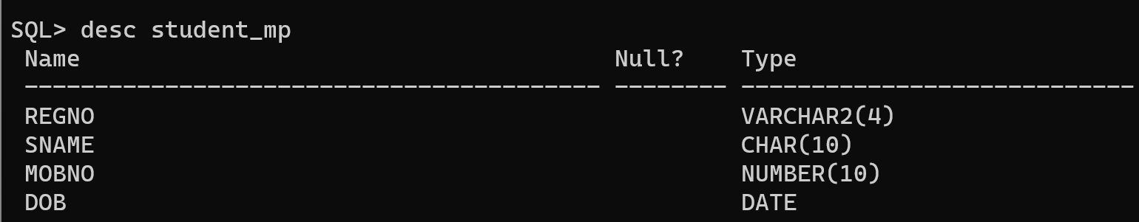

PL/SQL – Basics

- Write a PL/SQL structure to find a given number is Armstrong number or not, using loops.

[Individual digits cube is summed – result will be the original number]

Example 1:

a=153
b= 1³+5³+3³= 1+125+27=153
a=153 is equal to b=153, so 153 is an Armstrong number.

Example 2:

a=121
b= 1³+2³+1³= 1+8+1=10
a=121 is not equal to b=10, so 121 is not an Armstrong number.

- Write a PL/SQL structure to find addition, subtraction, multiplication and division of two numbers using ‘case’. Use the following strings to do the operations

Add = addition
Sub – subtraction
Mul – multiplication
Div – division
Mod - Modulus

- Get an input of a 4 digit number. Form a 3 digit pin number from the 4 digit input number. Pin number should be generated as follows:

Input: 7793, Output: 147

- First digit of the pin number should be the integer squareroot of the 4th digit of the input number. [Fourth digit of input is 3. Int(SQRT(3)) = 1]. So first digit of the pin is 1.
- Second digit of the pin number should be the 1st digit of the square of the 1st digit of the input number [First digit of input is 7. First digit of square(7) = 49 i.e 4]. So second digit of the pin is 4.
- Third digit of the pin number is the least addition of the second and the third number of the input number. [second number is 9, third number is 9. Least addition = 7+9 = 16 = 1+6= 7]. So third digit is 7.

